TryHackMe Rooms Assignment

Name: Vishal Chudasama
Division: E
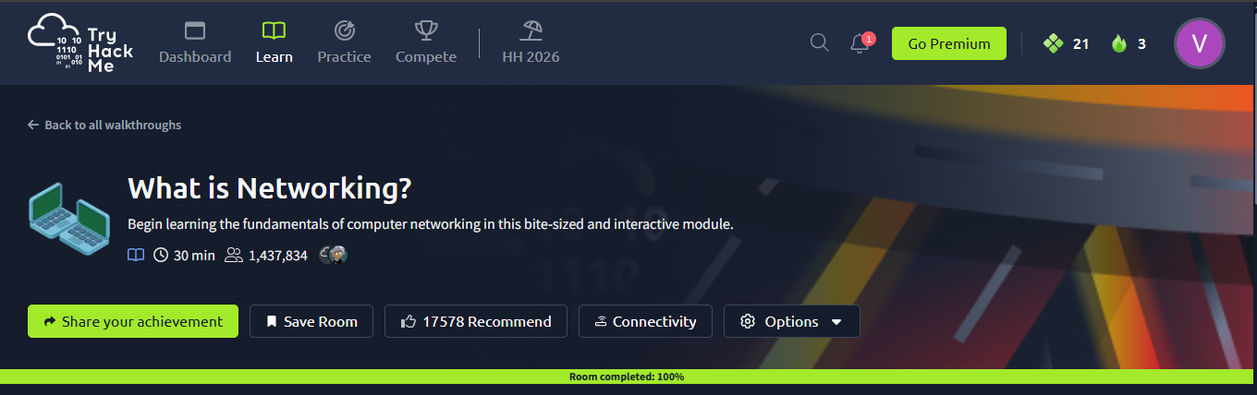
Enrollment Number: 25004401110069
Figure 1: What is Networking TryHackMe Room
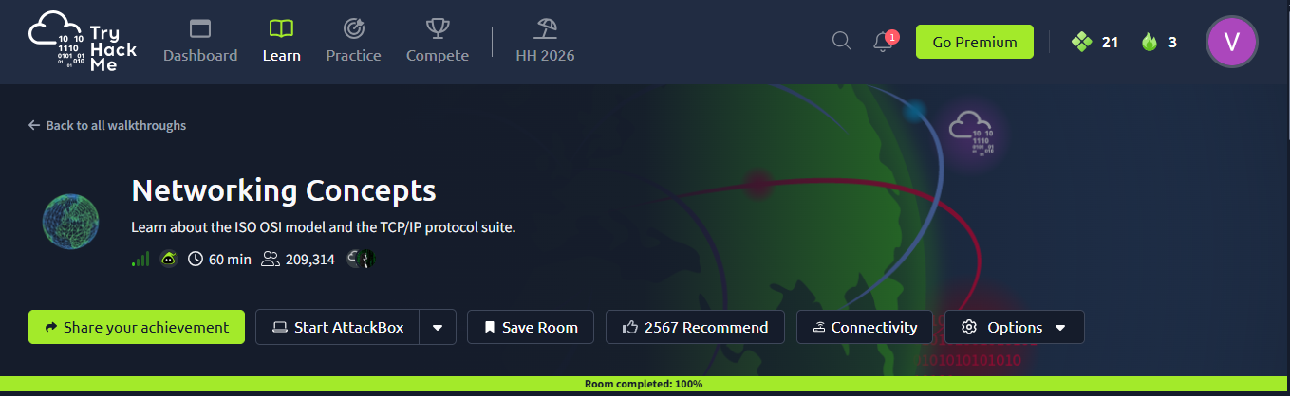
Figure 2: Networking Concepts TryHackMe Room

Figure 3: Intro to LAN TryHackMe Room

